**ELECTROPHOROSIS**

[**Definition of Electrophoresis**](http://www.chemicool.com/definition/electrophoresis.html)

[Electrophoresis](http://www.chemicool.com/definition/electrophoresis.html) is a separations technique that is based on the the mobility of ions in an electric [field](http://www.chemicool.com/definition/field.html). Positively charged ions migrate towards a negative electrode and negatively-charged ions migrate toward a positive electrode.For safety reasons one electrode is usually at ground and the other is biased positively or negatively. Ions have different [migration](http://www.chemicool.com/definition/migration.html) rates depending on their total charge, size, and shape, and can therefore be separated. Instrumentation An electrode apparatus consists of a high-voltage supply, electrodes, buffer, and a support for the [buffer](http://www.chemicool.com/definition/buffer.html) such as filter paper, [cellulose](http://www.chemicool.com/definition/cellulose.html) acetate strips, polyacrylamide gel, or a [capillary](http://www.chemicool.com/definition/capillary.html) [tube](http://www.chemicool.com/definition/tube.html). Open [capillary](http://www.chemicool.com/definition/capillary.html) tubes are used for many types of samples and the other supports are usually used for biological samples such as protein mixtures or [DNA](http://www.chemicool.com/definition/dna.html) fragments. After a separation is completed the support is stained to visualize the separated components.

[Resolution](http://www.chemicool.com/definition/resolution.html) can be greatly improved using [isoelectric](http://www.chemicool.com/definition/isoelectric.html) focusing. In this technique the support [gel](http://www.chemicool.com/definition/gel.html) maintains a [pH](http://www.chemicool.com/definition/ph.html) gradient. As a protein migrates down the gel, it reaches a [pH](http://www.chemicool.com/definition/ph.html) that is equal to its [isoelectric](http://www.chemicool.com/definition/isoelectric.html) point. At this [pH](http://www.chemicool.com/definition/ph.html) the protein is netural and no longer migrates, i.e, it is focused into a sharp [band](http://www.chemicool.com/definition/band.html) on the [gel](http://www.chemicool.com/definition/gel.html).

Schematic of zone [electrophoresis](http://www.chemicool.com/definition/electrophoresis.html) apparatus

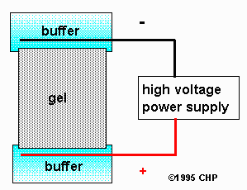 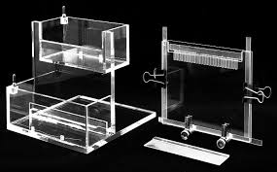

Specific electrophoretic techniques

* disc electrophoresis
* capillary electrophoresis
* gel [electrophoresis](http://www.chemicool.com/definition/electrophoresis.html) (SDS-PAGE)

# 3 Major Types & Applications

Electrophoresis is one of the widely used techniques in molecular [biochemistry](http://www.rajaha.com/importance-biochemistry/), [microbiology](http://www.rajaha.com/importance-microbiology/).

It is a type on of [protein separation](http://ccnmtl.columbia.edu/projects/biology/lecture5/protseps.html) method.

It is one of the highly efficient techniques of analysis and sole method for separation of proteins for western blot, RNA studies etc. But, on negative side it also time-consuming, expensive and technical skilled procedure due to which is less preferred in [healthcare](http://www.rajaha.com/careers-in-healthcare/). It is a both [qualitative](http://www.rajaha.com/qualitative-analysis-methods/) and [quantitative](http://www.rajaha.com/quantitative-analysis-methods-techniques/) analysis technique. Electrophoresis is similar to other separation techniques like [chromatography](http://www.rajaha.com/chromatography-definition-principle-techniques/) but it differs in-terms of the types of samples analyzed, the method used for separation, principle used etc.

### [http://www.rajaha.com/wp-content/uploads/2012/10/gel-electrophoresis-300x201.jpg](http://www.rajaha.com/electrophoresis-principle-types-techniques/gel-electrophoresis/)C:\Documents and Settings\senthil\Desktop\untitled.jpg

### ELECTROPHORESIS PRINCIPLE

Electrophoresis is a method of separation of charged molecules in an electric field so as to make them migrate towards opposite charged electrodes. The migration is due to charge on the molecules and potential applied across the electrodes.  These molecules migrate at different speed and to different lengths based on their charge, mass and shape.

[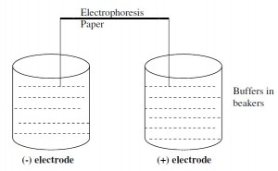](http://www.rajaha.com/electrophoresis-principle-types-techniques/paper-electrophoresis/)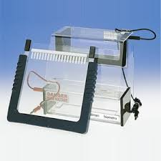

### TYPES OF ELECTROPHORESIS & THEIR TECHNIQUES.

Electrophoresis can be broadly divided into 3 types

* Zone electrophoresis
* Isoelectro-focusing
* Immune-electrophoresis.

**Zone electrophoresis**: Here the charged particles are separated into different zones or bands. This is of two types as

1. Paper electrophoresis.

Gel electrophoresis.

Paper electrophoresis is a techniques which employs a Whatman filter paper No.1 which is moistened by a buffer and then connected at two ends to two opposite charged electrodes. Then sample is applied on to one end and let for separation of components under electric field. After separation, the paper is dried and stained to get colored bands. These colored bands are recognized for the nature of sample by comparing with the standard. For a sample of serum, 5 bands of proteins can be separated by paper electrophoresis.



Gel electrophoresis is a similar techniques wherein instead of paper, a gel made of agarose or SDS (sodium dodecyl sulphate). The separation is more efficient than paper type as the rate of movement is slow and area of separation is larger by thickness. The sample is applied and subjected to electric field which can lead to separation of molecules. These molecules form bands and can be recognized by staining and comparing with standard sample bands. The method is more effective than paper and for instance from serum sample, 15 proteins bands can be isolated.

**Isoelectro-focusing:** Here the iso-electric pH is set at different foci and hence the molecules are immobilized to their iso-electric point. They don’t move towards electrodes but stay at a specific isoelectric pH. This is even more efficient to separate proteins and from serum, 40 bands of protein can be formed.

**Immuno electrophoresis**: This is the method with combination of principles of both electrophoresis with immune reactions. First the proteins are separated on to the electrophoresis paper. Then the antibodies are allowed to diffuse through the paper and react with separated protein molecules in bands.

Also read other immuno assay reactions

♣ [Principle and types of elisa](http://www.rajaha.com/elisa-test-what-principle-types/).    ♣ [Radio immuno assay](http://www.rajaha.com/radio-immuno-assay-principle-procedure-ria/).

Both of the methods are very specific and highly sensitive and widely used in [microbiology](http://www.rajaha.com/methods-sterilization/).

#### APPLICATIONS OF ELECTROPHORESIS:

1. To separate complex molecules: Many complex biological molecules like vitamins B12. antibiotics, proteins can be separated efficiently by electrophoresis. This is possible due to charge difference among the mixtures.

2. For analysis of nucleic acid molecules like RNA and DNA studies. These long chain molecules can be analyzed only after separation after electrophoresis. This helps to determine the size or breaks in the DNA or RNA molecule.